Local Features to be extracted from each triplet

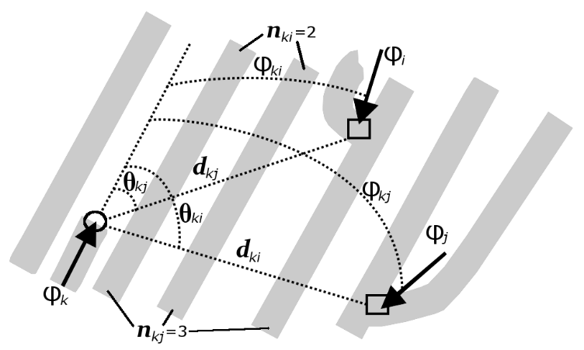

- $Side ratios: \left\{\begin{matrix}\frac{a}{b}, & \frac{b}{c}\end{matrix}\right\}$ where, c is the largest side of the triangle
- Two internal angle (Least two)
- Normalized Area: $\frac{A}{c^{2}}$
- Inradius to Circumradius: r/R
- Orientation difference
- Local Ridge Frequency: How many ridges pass through a small window around a minutia, per unit distance.
- Local Ridge Orientation Field Smoothness:

Extract Local Ridge Orientation Field
- Divide the fingerprint image into small blocks (e.g., 16×16 pixels).
- For each block, compute the dominant ridge orientation (using gradients or FFT).
- Represent orientation as angle θ (0–180°).
Pick a Minutia Point
- Take a minutia (say, a ridge ending at (x,y)).
- Define a neighborhood radius R around it (e.g., 40 pixels).
Collect Neighbor Orientations
- Get the ridge orientations of blocks within this neighborhood.
- Say we get angles: θ₁, θ₂, θ₃ … θₙ.
Compute Smoothness Measure
- If all θᵢ ≈ same → smooth.
- If θᵢ vary a lot → rough.
- Mathematically:
  - Compute circular variance of orientations:
$$S=1-\frac{\sqrt{{\left(cos{ }2θ_{i}\right)}^{2}+{\left(\sin{2θ_{i}}\right)}^{2}}}{n}$$
  - S ≈ 0 → smooth (low variation).
  - S ≈ 1 → rough (high variation).
- Ridge Orientation Dispersion

- Pick a minutiae
Suppose you have a minutia point M (ridge ending or bifurcation).
- Draw a small circle around it
Radius: e.g., 30 pixels.
This is the neighborhood of interest.
- Measure ridge directions inside the circle
  - At several points inside the circle, find the local ridge orientation angle (θ).
  - You’ll get a set of orientation values: {θ1,θ2,…,θn}
- Compute dispersion of directions
  - If all θ’s are nearly the same → ridges flow smoothly.
  - If θ’s vary a lot (fan-out, swirl) → disturbed flow.

Global Features to be extracted from each triplet
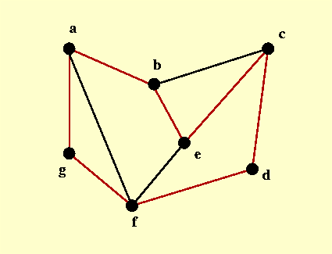

    - Adjacency degree (how many neighboring triangles share a side/vertex):
      - For triangle T, count the number of distinct triangles that share an edge with it.
      - That number = adjacency degree of T
    - Shared edge consistency:

Let triangles $T_{i}$​ and $T_{j}$​ share edge e whose endpoints are U and V.
- a1​=∥U−P∥, a2=∥U−Q∥
(lengths of edges at vertex U in the two triangles)
- b1=∥V−P∥, b2=∥V−Q∥
lengths of edges at vertex V)
- αi​ = angle in Ti opposite edge UV (at P)
- αj​ = angle in Tj opposite edge UV (at Q)

    - Adjacent-edge length consistency
$$S_{L}=1-\frac{1}{2}( \frac{\left|a_{1}-a_{2}\right|}{\max\left(a_{1},a_{2}\right)}+ \frac{|b_{1}-b_{2}|}{max⁡(b_{1},b_{2})})$$
    - Opposite-angle consistency
$$∆α=min(\left|α_{i}-α_{j}\right|, 2π-|α_{i}-α_{j}| )$$
$S_{α}=1-\frac{∆α}{π}$
    - Combined Score
$R2=0.5 S_{L}+0.5 S_{α}$

    - Area ratio between neighbours:

For adjacent triangles $T_{i}$​ and $T_{j}$​:
$R_{area}​(i,j)=\frac{min\left(A_{i}​,A_{j}​\right)}{max\left(Ai​,Aj​\right)} ​$

